BillChill

Version <1.0>

Revision History

|  |  |  |  |
| --- | --- | --- | --- |
| **Date** | **Version** | **Description** | **Author** |
| 25.10.2016 | 1.0 | Initial version | Hannes, Emil, Nicolas |
|  |  |  |  |
|  |  |  |  |
|  |  |  |  |

Table of Contents

1. Introduction 3

1.1 Purpose 3

1.2 Scope 3

1.3 Definitions, Acronyms, and Abbreviations 3

1.4 References 3

1.5 Overview 3

2. Overall Description 3

3. Specific Requirements 3

3.1 Functionality 3

3.1.1 <Functional Requirement One> 3

3.2 Usability 3

3.2.1 <Usability Requirement One> 3

3.3 Reliability 3

3.3.1 <Reliability Requirement One> 3

3.4 Performance 3

3.4.1 <Performance Requirement One> 3

3.5 Supportability 3

3.5.1 <Supportability Requirement One> 3

3.6 Design Constraints 3

3.6.1 <Design Constraint One> 3

3.7 On-line User Documentation and Help System Requirements 3

3.8 Purchased Components 3

3.9 Interfaces 3

3.9.1 User Interfaces 3

3.9.2 Hardware Interfaces 3

3.9.3 Software Interfaces 3

3.9.4 Communications Interfaces 3

3.10 Licensing Requirements 3

3.11 Legal, Copyright, and Other Notices 3

3.12 Applicable Standards 3

4. Supporting Information 3

# Introduction

## Purpose

This Software Requirements Specification (SRS) will give detailed information about the requirements of BillChill.

## Scope

The document is for our internal use and will help us to develop this project.

## Definitions, Acronyms, and Abbreviations

|  |  |  |
| --- | --- | --- |
| SRS | Software Requirements Specification | |
| CB | BillChill | |
| App | Application |
|  |  |

## References

GIT-Hub:

BillChill Website: https://billchill.wordpress.com/

## Overview

We decided to develop this application because it was often very annoying and difficult to split the bill for example in holidays. In the following part of the SRS we will describe the application in detail going into specification requirements like functionality, usability and performance for example.

# Overall Description

BillChill improves the process of splitting bills on common events because it has a very easy handling. You will be able to save entries for long periods. So you needn´t to split the bills after every common event.

# Specific Requirements

## Functionality

### Use-Case Diagram

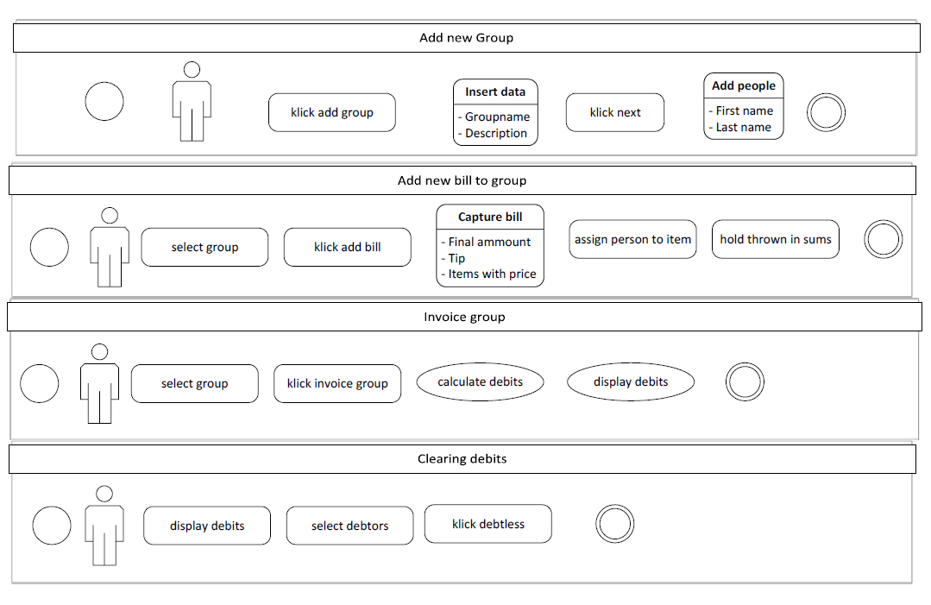

### Features of BillChill

At first we will develop BillChill in an offline mode. We will develop a database in order to save all the entries for longer periods. A user will be able to create groups and add bills in them. The application will settle these invoices immediately. Optional features of BillChill will be an online mode and a functionality to scan a bill in a restaurant for example. We will include these features at the end of the project if there is enough time left.

## Reliability

The offline mode should be reliable. If we include the online mode there may be some problems with the server.

## Performance

The application should have a proper performance. There can be some constraints implementing an online mode

## Supportability

## Design Constraints

## On-line User Documentation and Help System Requirements

## Purchased Components

## Interfaces

## Licensing Requirements

## Legal, Copyright, and Other Notices

## Applicable Standards

# Supporting Information